build a Task Management App using React

We will be using React Hooks, CSS for styling and HTML

steps to Run the project:

Run this command to create a React application named Task-mgt-app:

npx create-react-app Task-mgt-app

The create-react-app will set up everything you need to run a React application.

Run the React Application

Now you are ready to run your first *real* React application!

Run this command to move to the Task-mgt-app directory:

cd Task-mgt-app

Run this command to run the React application Task-mgt-app:

npm start

A new browser window will pop up with your newly created React App! If not, open your browser and type localhost:3000  need to run a Applicatio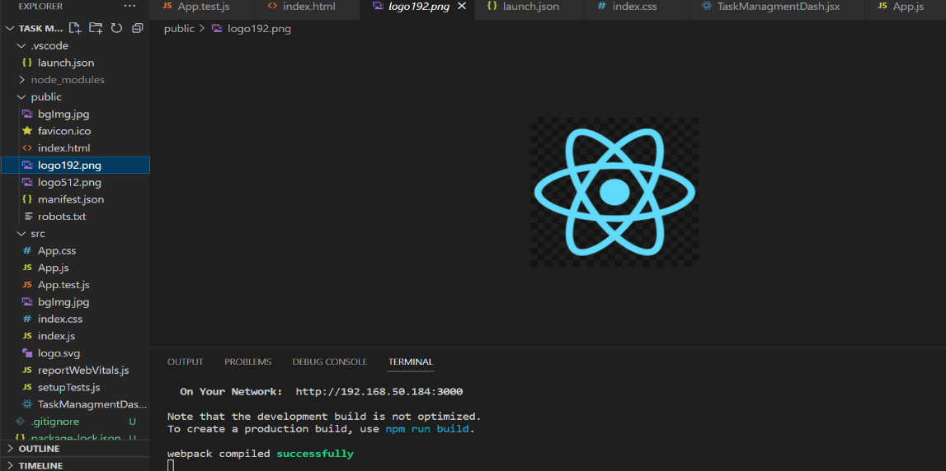

The TASK MGT APP is the project name will be created successfully.

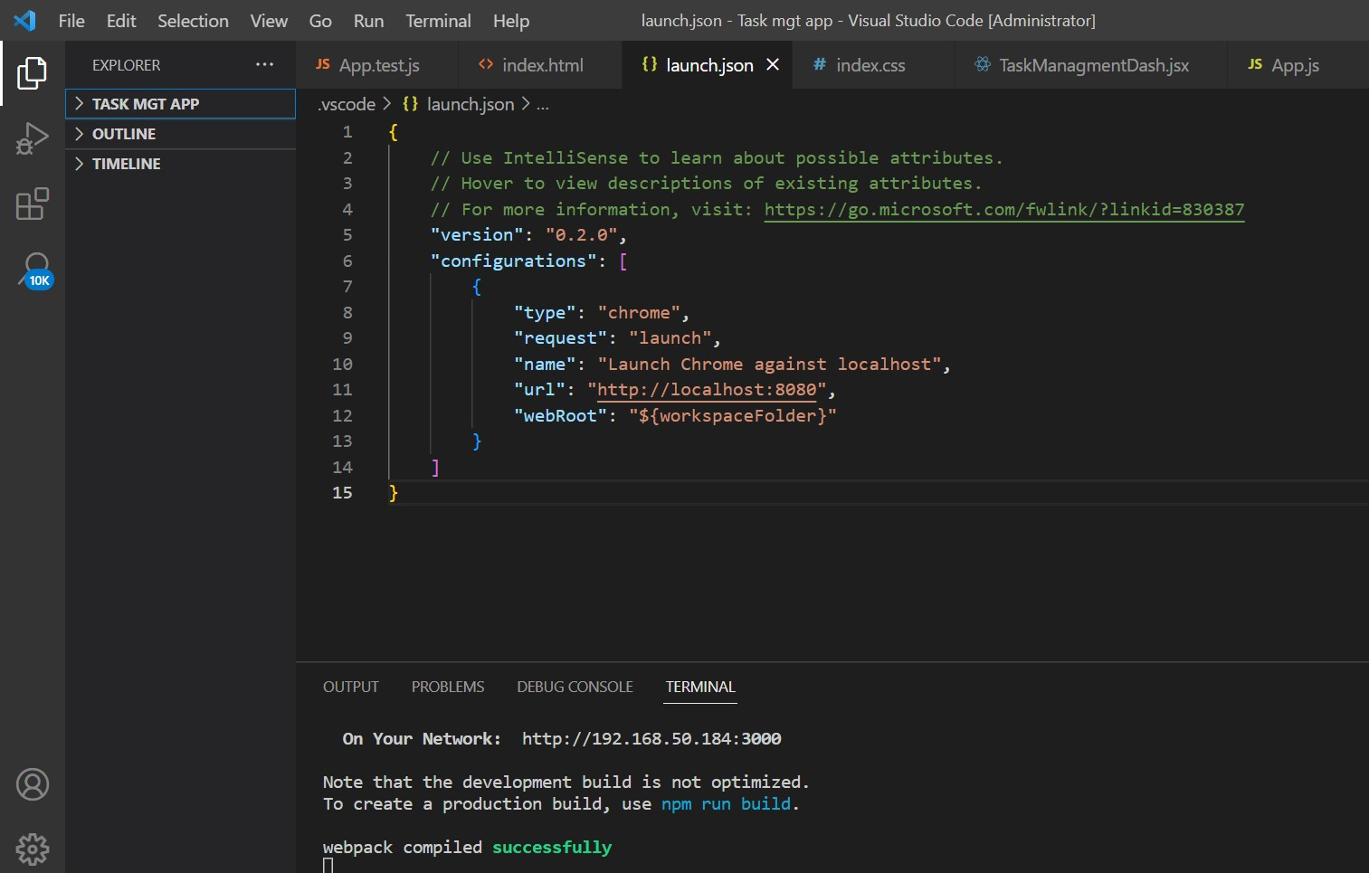

SRC will be created Successfully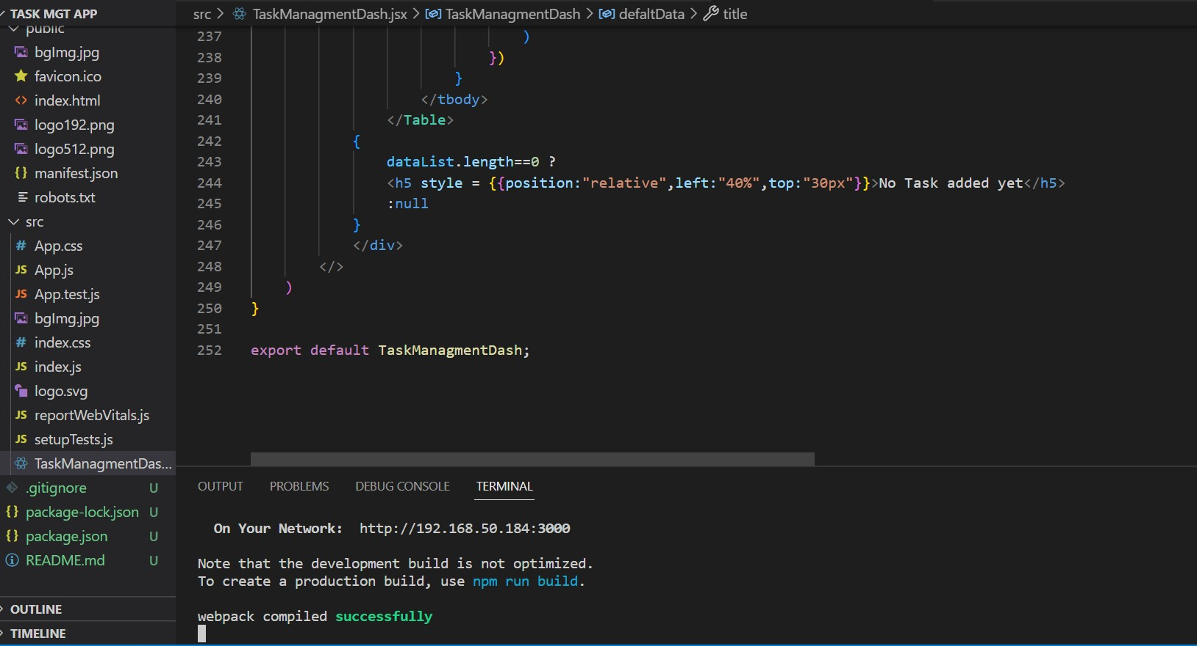

The Code Successfully Compiled

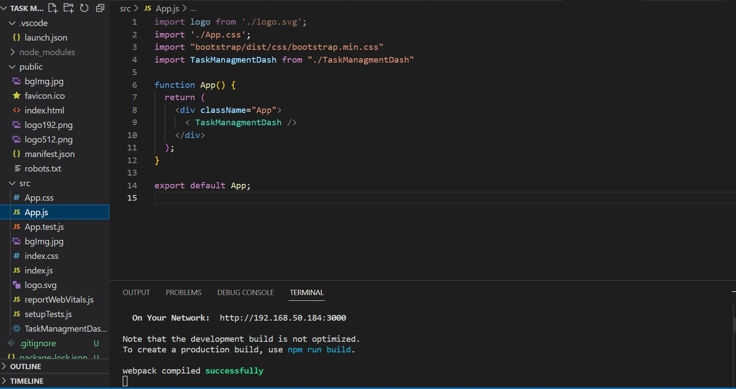

Output images :

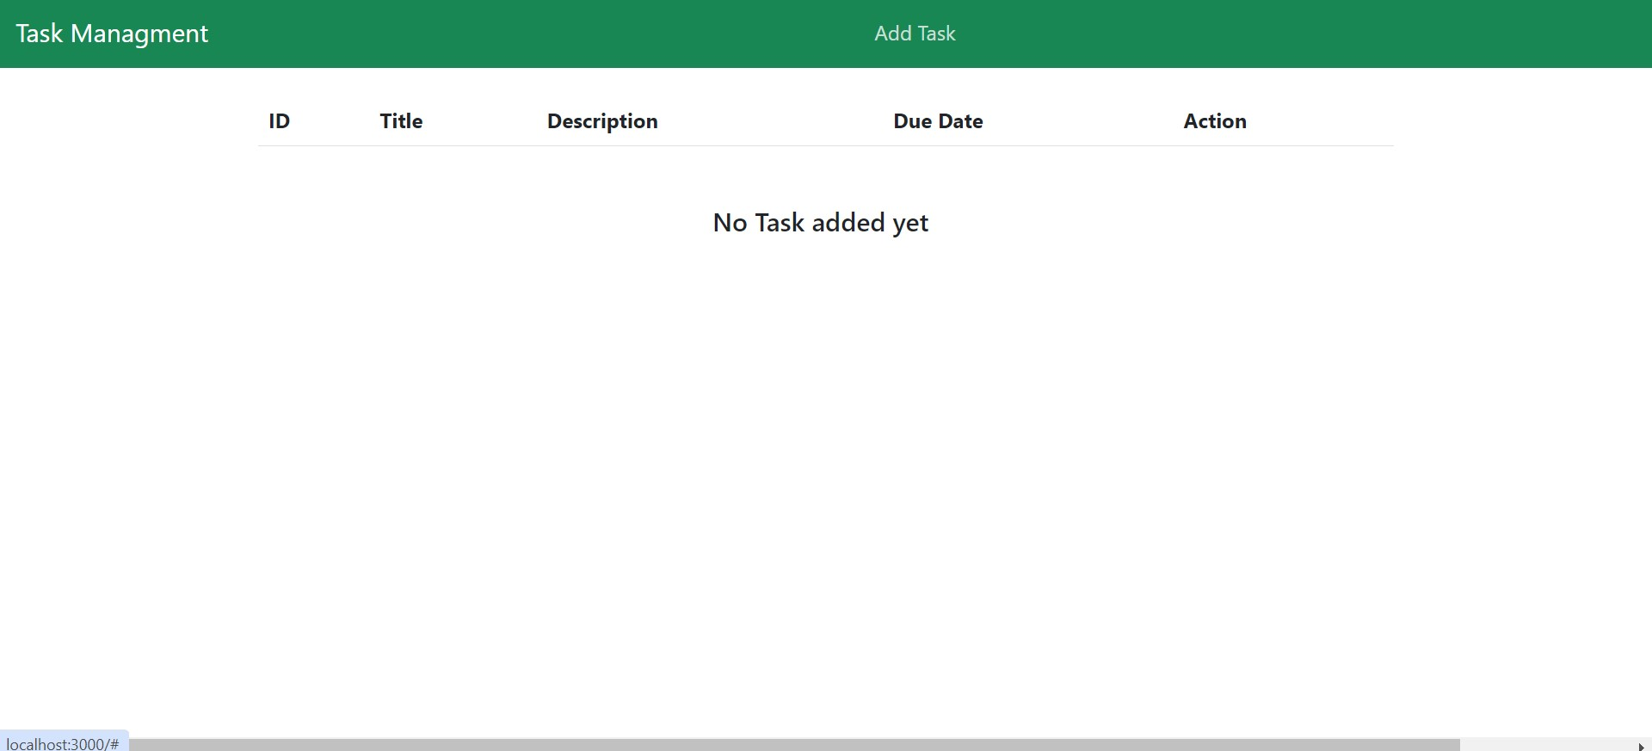

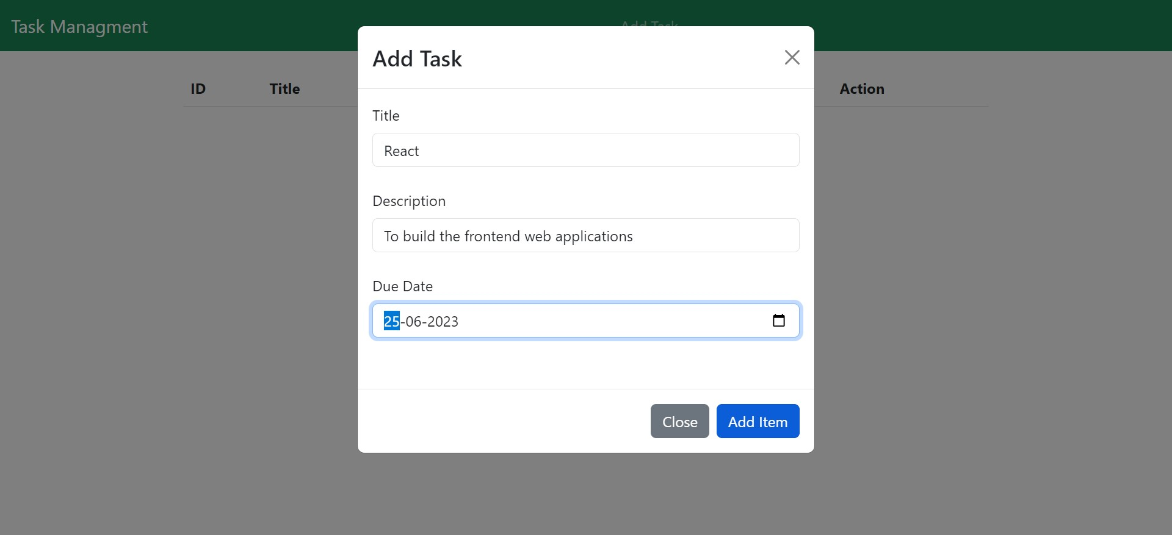

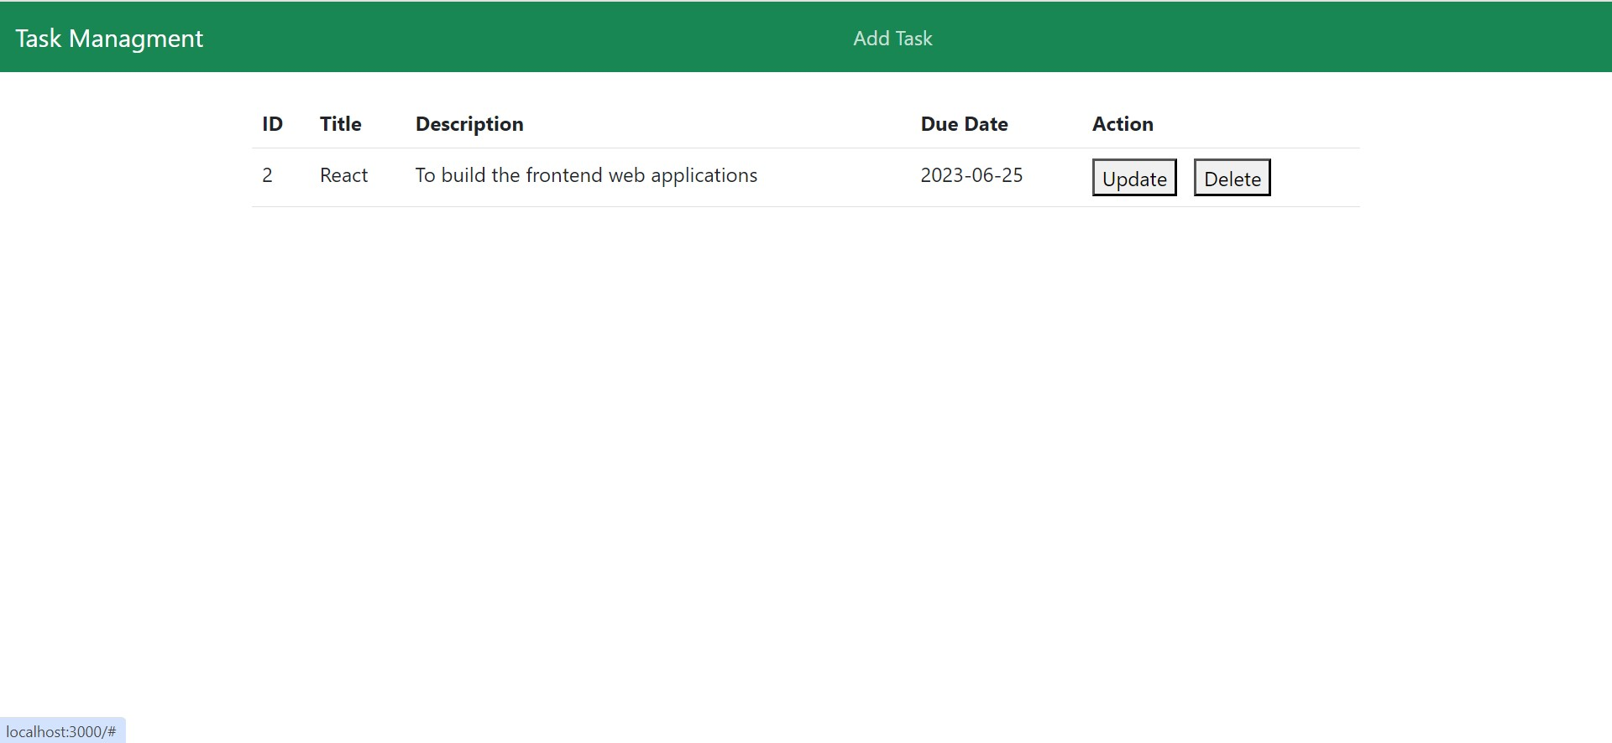

Update the data